**THE PEPERRONI**

**APP**

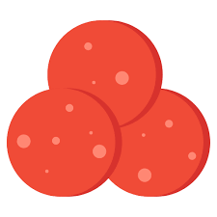



# Purpose of this application

The purpose of this application is to **view a list pizza of the Peperoni restaurant**

Two kind of users can login to the application:

* As a **customer**, I can sign in, sign up, and sign out of the application
* As a **customer**, I can view the pizzas
* As a **manager**, I can create pizzas, with the pizza ingredients and prize

A manager has access to the same features than the customer:

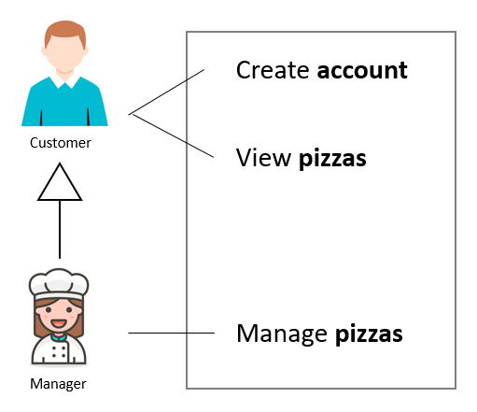

# Planning

**The project must respect the deadlines and must be finished within in 6 days**

**You need to work at least 8 hours per day to finish it on time**

|  |  |  |
| --- | --- | --- |
| DAY | FEATURES | TASK |
| DAY 1 | Manage accounts | #1 – Database design / creation  #2 - Sign in view |
| DAY 2 | #3- Sign up view |
| DAY 3 | #4 - Main view (pizza view) |
| DAY 4 | Manage pizzas | #5 – pizza view list |
| DAY 5 | #6 – Add/Edit pizza pop up |
| DAY 6 | #7 – Remove pizza |
| DAY 7 | Bugs and code quality | #8 – Refactoring and bug fix |

# EVALUATION

|  |  |
| --- | --- |
| EVALUATION TOPIC | EVALUATION POINTS |
| Database design is correct | 10 |
| Sign in view | 15 |
| Sign up view | 10 |
| Log out and return to the sign in view | 10 |
| Pizza list view | 15 |
| Add/Edit/Remove pizza | 20 |
| **Code quality** : following the guide | 20 |
| **TOTAL** | **100** |

# FEATURE 1 - Manage accounts (3 days)

It shall be possible to:

* Sign up (create an account)
* Sign in (connect to the application)
* Sign out (disconnection from the application)

Tasks related to this feature:

|  |  |
| --- | --- |
| TASK ID | DESCRIPTION |
| #1 | Design and create database |
| #2 | Sign in view |
| #3 | Sign up view |
| #4 | Main view and logout action |

**#1 – Database design and creation**

Regarding this specification, create the database diagram and the required tables for this project

**#2 - Sign in view**

This view displays 2 fields:

* login
* password
* When
  + clicking on **NEXT button**
  + **or press ENTER:**

If login and password match, the **pizza view** is displayed

* + - **Application is now opened with the user who logged in**
  + Otherwise display error and on this view
* When clicking on **CREATE ACCOUNT**, the **sign up** **view** shall be displayed instead

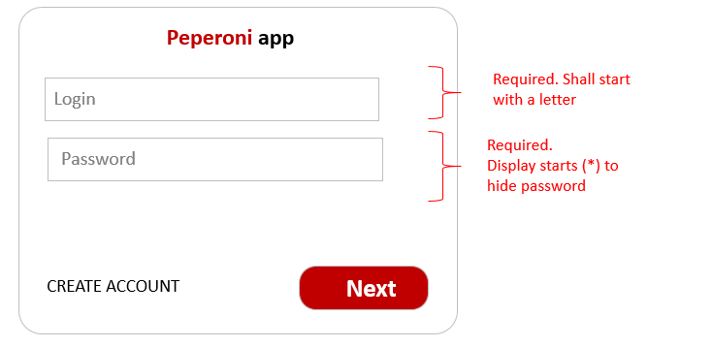

**#3- Sign up view**

* When
  + clicking on **NEXT button**
  + **or press ENTER:**

If all fields are correct, the **pizza view is** displayed

* + - **A new user is added to the database**
    - **Application is now opened with the user who logged in**
  + Otherwise display error and on this view
* When clicking on **SIGN IN INSTEAD**, the **sign in** **view** shall be displayed instead

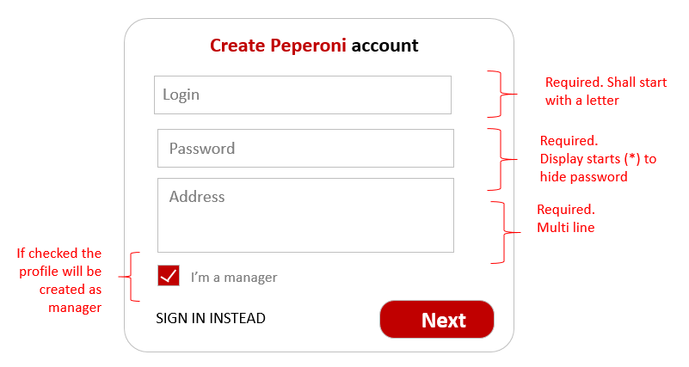

**#4 - Main view (pizza view)**

For now the pizza view is empty and should just context the sign out action:

* When clicking on **SIGN OUT:**
  + The session is cleared and the sign in view is displayed again

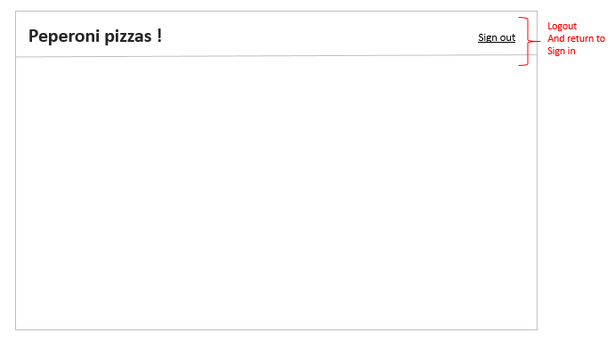

**Interaction diagram** between the 3 views:

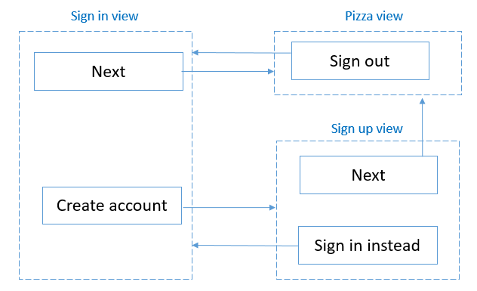

FEATURE 2 - Manage pizzas

It shall be possible to:

* Add a new pizza type
* Remove a pizza type
* Update a pizza type

|  |  |
| --- | --- |
| TASK ID | DESCRIPTION |
| #5 | pizza view list |
| #6 | Add/Edit pizza pop up |
| #7 | Remove pizza |

**#5 - Pizza view list**

View restriction

* **ADD** action is accessible only for managers
* **EDIT** action is accessible only for managers
* **REMOVE** action is accessible only for managers

This view displays the list of pizzas the manager is offering to the customers:

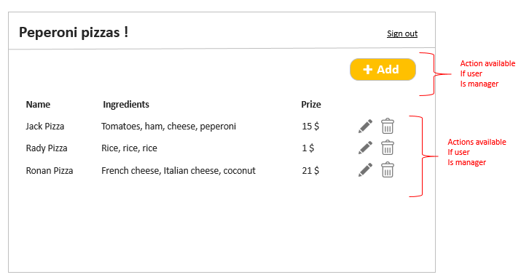

A pizza has 3 properties:

* Name
* List of ingredients
* Prize

Actions

* When clicking on remove button, the related pizza is removed
* When clicking on edit button, the edit pop up is displayed (modal dialog)
* When clicking on add button, the add pop up is displayed (modal dialog)

**#5 – Add/Edit pizza pop up**

* Errors shall be displayed when filed are missing or value are not correct (see below)
* The button CREATE/UPDATE shall be disabled if errors exist in the dialog

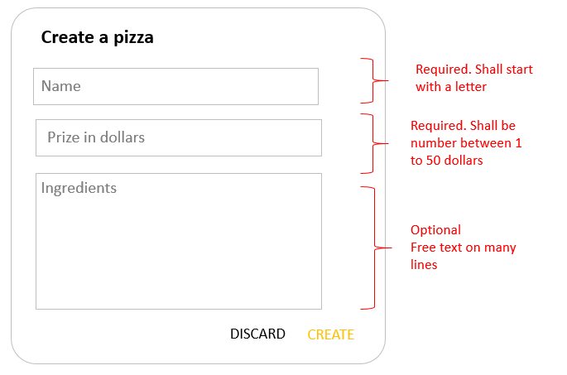

*CREATE pop up*

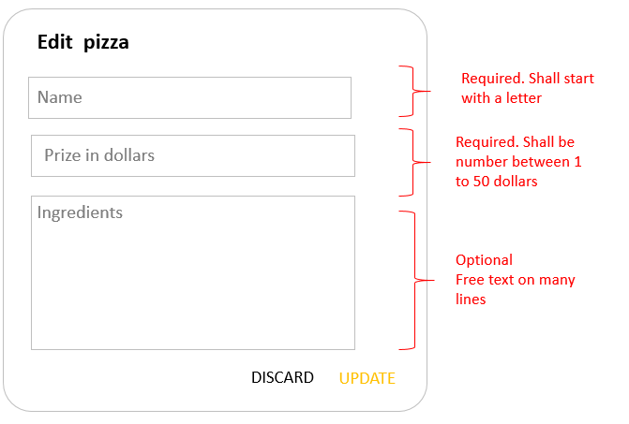

*CREATE pop up*

* When:
  + Pressing **ENTER**
  + or clicking on **UPDATE** or **CREATE** button

The dialog is closed and the pizza list must be updated

Note: we don’t have to refresh the page to see the updated list

Note:

* You might need to think how to factorize you code to avoid to duplicate 2 views ad controllers for the 2 pop ups

**#6 – Remove pizza**

* When clicking on **REMOVE** button the pizza is removed and the pizza list must be updated
  + Note : we don’t have to refresh the page to see the updated list

# LAST DAY - Bug fix and code quality

The last day should be dedicated to

* Fix the last bugs
* Improve the quality of your code after your teacher feedbacks
* Code review and correction